***Fundamentals of Programming***

***LAB Manual 2***

*m*

**Name: Muhammad Abdullah**

**Class: ME-15 A**

**Roll number: 454502**

1. **Create a program that takes a student's score as input and assigns a grade based on predefined criteria using logical operators (e.g., A, B, C, D, F). A-Grade: 90-100 Marks B-Grade: 75-90 Marks C-Grade: 60-75 Marks D-Grade: 45-60 Marks F-Grade: 0-45 Marks**

int main(){

int score;

//asking the user to enter score

cout<<"please enter the score of the student"<<endl;

cin>> score;

//using conditional statement to compare score to calculate grade

if (score>=90 && score<=100)

{cout<<"A grade"<<endl;

}

else if (score>=75&& score<90)

{ cout<<"B grade"<<endl;}

else if (score>=60&& score<75)

{ cout<<"C grade"<<endl;}

else if (score>=45&& score<60)

{ cout<<"D grade"<<endl;}

else if (score>=0&& score<45)

{ cout<<"F grade"<<endl;}

return 0; }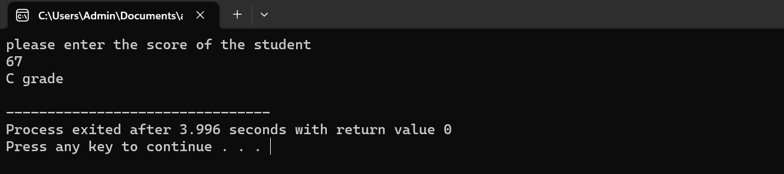

1. **Write a program that takes an integer as input and determines if it is both even and divisible by 5.**

int main(){

int num;

//prompt the user to enter number

cout<<"please enter the number you want to check"<<endl;

cin>>num;

//comparing its remainder after division by 2, to see if its even using conditional statement

if (num%2==0){

//checking if its divisible by 5 or not

if(num%5==0){cout<<"number is an even number and is divisible by 5"<<endl;

}

else{cout<<"num is even number, but is not divisible by 5"<<endl;

}

}

else if (num%5==0){cout<<"number is not even but is divisible by 5"<<endl;

}

else{cout<<"number is neither even, nor divisible by 5"<<endl;

**}**

**return 0;**

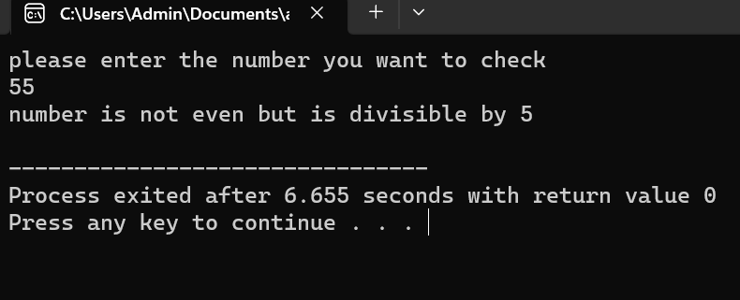

1. **Create a C++ program that checks if a user-provided year is a leap year.**

int main(){

int year;

//asking user to enter year

cout<<"please enter the year"<<endl;

cin>>year;

//using if statement to check if its leap year

if (year%4==0 && year%100 !=0)

//outputting the result

{cout<<"year is a leap year"<<endl;

}

else if (year%400==0){

cout<<"year is a leap year"<<endl;

}

else{cout<<"year is not a leap year"<<endl;

}

return 0;

}

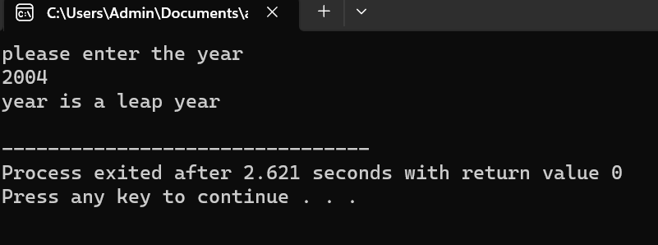

1. **Create a C++ program that determines if a student is eligible for a scholarship based on their GPA (must have GPA >= 3.5) and attendance (must have attended at least 80% of classes).**

int main(){

float gpa;

int attendance;

//asking the user to enter gpa and attendance

cout<<"please enter gpa and attendence of the students"<<endl;

cin>> gpa;

cin>>attendance;

//checking if gpa and attendance meets the criteria for scholarship

if (gpa>= 3.5 && attendance>=80){

//outputting results

cout<<"student is eligible for scholarship"<<endl;

}

else{cout<<"student is not eligible for scholarship"<<endl;

}

return 0;

}

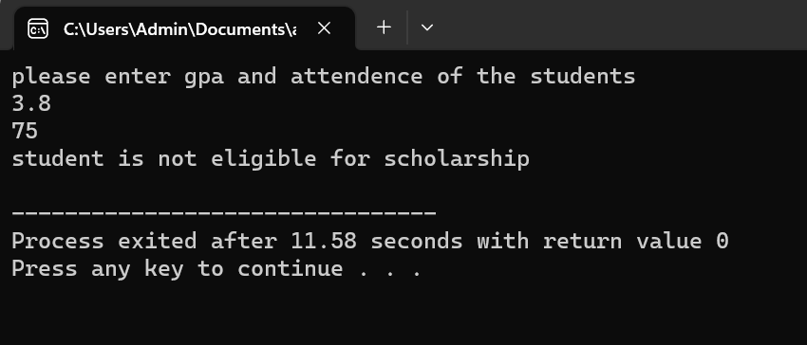

1. **Write a program that checks if a given character is a vowel (a, e, i, o, u) or a consonant using logical operators.**

int main(){

char character;

cout<<"please enter the alphabet"<<endl;

cin>>character;

if (character=='a'|| character=='e'|| character=='i'|| character=='o'|| character=='u')

{cout<<"alphabet is vowel"<<endl;

}

else{cout<<"alphabet is consonent"<<endl;

}

return 0;

}

